
Semester Two
Examination, 2024
Question/Answer Booklet

HUMAN BIOLOGY
UNIT 2

Name: __________________________________________________________

Teacher: ______________________________________________________

Time allowed for this paper

Reading time before commencing work: ten minutes
Working time for the paper: two hours and thirty minutes

Materials required/recommended for this paper
To be provided by the supervisor
This Question/Answer Booklet
Multiple-choice Answer Sheet

To be provided by the candidate
Standard items: pens (blue/black preferred), pencils (including coloured), sharpener, correction fluid/tape, eraser, ruler, highlighters

Special items: up to three calculators, which do not have the capacity to create or store programmes or text, are permitted in this ATAR course examination

Important note to candidates
No other items may be taken into the examination room. It is your responsibility to ensure that you do not have any unauthorised material. If you have any unauthorised material with you, hand it to the supervisor before reading any further.
Structure of this paper

Section | Number of questions available | Number of questions to be answered | Suggested working time (minutes) | Marks available | Percentage of examination
Section One Multiple-choice | 25 | 25 | 30 | 25 | 30
Section Two Short answer | 6 | 6 | 80 | 88 | 50
Section Three Extended answer  Unit 2 | 1 | 1 | 40 | 15 | 20
Unit 2 | 1 | 1 |  | 20
 |  |  | Total | 148 | 100
Instructions to candidates

1. The rules for the conduct of the Western Australian examinations are detailed in the Year 12 Information Handbook 2024: Part II Examinations. Sitting this examination implies that you agree to abide by these rules.

2. Write your answers in this Question/Answer booklet preferably using a blue/black pen. Do not use erasable or gel pens.

3. Answer the questions according to the following instructions.

Section One: Answer all questions on the separate Multiple-choice answer sheet provided. For each question, shade the box to indicate your answer. Use only a blue or black pen to shade the boxes. Do not use erasable or gel pens. If you make a mistake, place a cross through that square, then shade your new answer. Do not erase or use correction fluid/tape. Marks will not be deducted for incorrect answers. No marks will be given if more than one answer is completed for any question.

Section Two: Write your answers in this Question/Answer booklet. Wherever possible, confine your answers to the line spaces provided.

Section Three: Consists of two parts each with two questions. You must answer one question from each part. Tick the box next to the question you are answering. Write your answers in this Question/Answer booklet

4. You must be careful to confine your answers to the specific questions asked and to follow any instructions that are specific to a particular question.

5. Supplementary pages for planning/continuing your answers to questions are provided at the end of this Question/Answer booklet. If you use these pages to continue an answer, indicate at the original answer where the answer is continued, i.e. give the page number.

Section One: Multiple-choice 30% (25 Marks)

This section has 25 questions. Answer all questions on the separate Multiple-choice answer sheet provided. For each question, shade the box to indicate your answer. Use only a blue or black pen to shade the boxes. Do not use erasable of gel pens. If you make a mistake, place a cross through that square, then shade your new answer. Do not erase or use correction fluid/tape. Marks will not be deducted for incorrect answers. No marks will be given if more than one answer is completed for any question.

Suggested working time: 40 minutes.

1. The process whereby chromosomes separate during the first meiotic division, leading to variation in alleles in the gametes, is known as

(a) random fertilsation.
(b) non-disjunction.
(c) independent assortment.
(d) crossing over.

2. Andrea, who has the autosomal recessive condition known as cystic fibrosis (CF), marries a man whom has no history of CF in his family. What is the most likely probability, as a percentage, of their children having CF?

(a) 0%
(b) 25%
(c) 75%
(d) 100%

3. Follicle stimulating hormone is released from the

(a) ovaries.
(b) testes.
(c) corpus luteum.
(d) pituitary gland.

4. Which of the following contraception methods cannot help prevent transmission of sexually transmitted infections?

(a) chemical spermicides
(b) condoms
(c) abstinence
(d) female condoms

Questions 5 to 7 refer to the following diagram showing the process of meiosis.

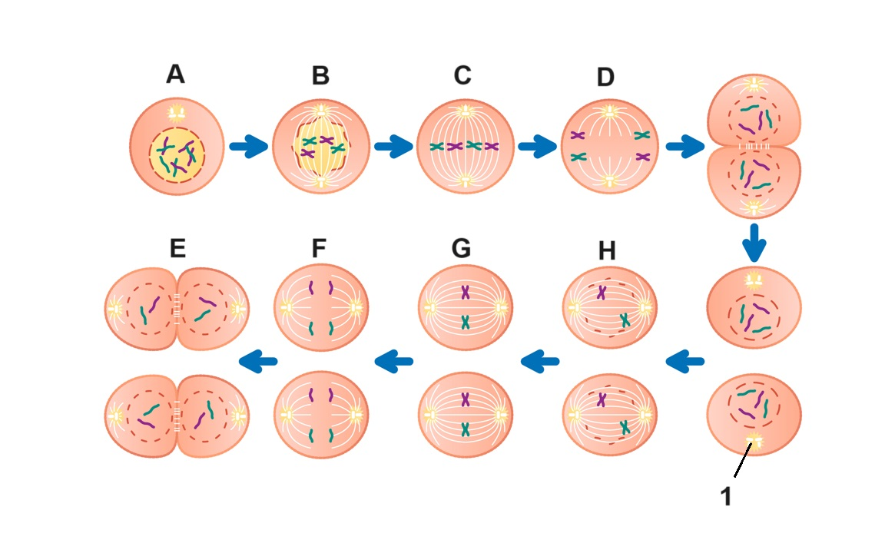

5. During which of the phases labelled on the diagram does crossing over occur?

(a) A
(b) B
(c) C
(d) D

6. The organelles labelled with the number 1 are known as

(a) centromeres.
(b) chromatin.
(c) microtubules.
(d) centrioles.

7. During oogenesis, in which phase labelled on the diagram above does meiosis stop at, after ovulation occurs?

(a) E
(b) F
(c) G
(d) H

8. Which of the following structures is not formed by the mesoderm during embryonic development?

(a) cartilage
(b) lymphoid tissue
(c) hair
(d) muscles

Question 9 and 10 refer to the following pedigree chart showing the inheritance of alleles that results in the production of the antigens from the ABO blood grouping system. The shaded individuals have type O blood.

Note: this pedigree does not include information about inheritance of the Rhesus factor.

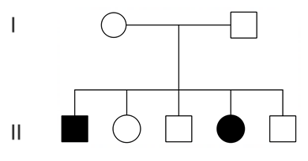

9. Which of the following is the correct annotation for the genotype of the shaded individuals?

(a) ii
(b) oo
(c) IºIº
(d) II

10. If the female in generation I has type A, and the male has type B blood, what type of blood do their children without type O have?

(a) type A
(b) type B
(c) type AB
(d) not enough information provided to determine blood type

11. Which of the following terms refers to how correct, or true, the results of an investigation are?

(a) reliability
(b) validity
(c) accuracy
(d) precision

12. A Pap smear is a test that can be used to identify abnormal cells that could lead to the development of

(a) cervical cancer.
(b) prostate cancer.
(c) bowel cancer.
(d) breast cancer.

Question 13, 14 and 15 refer to the diagram below of the cell membrane.

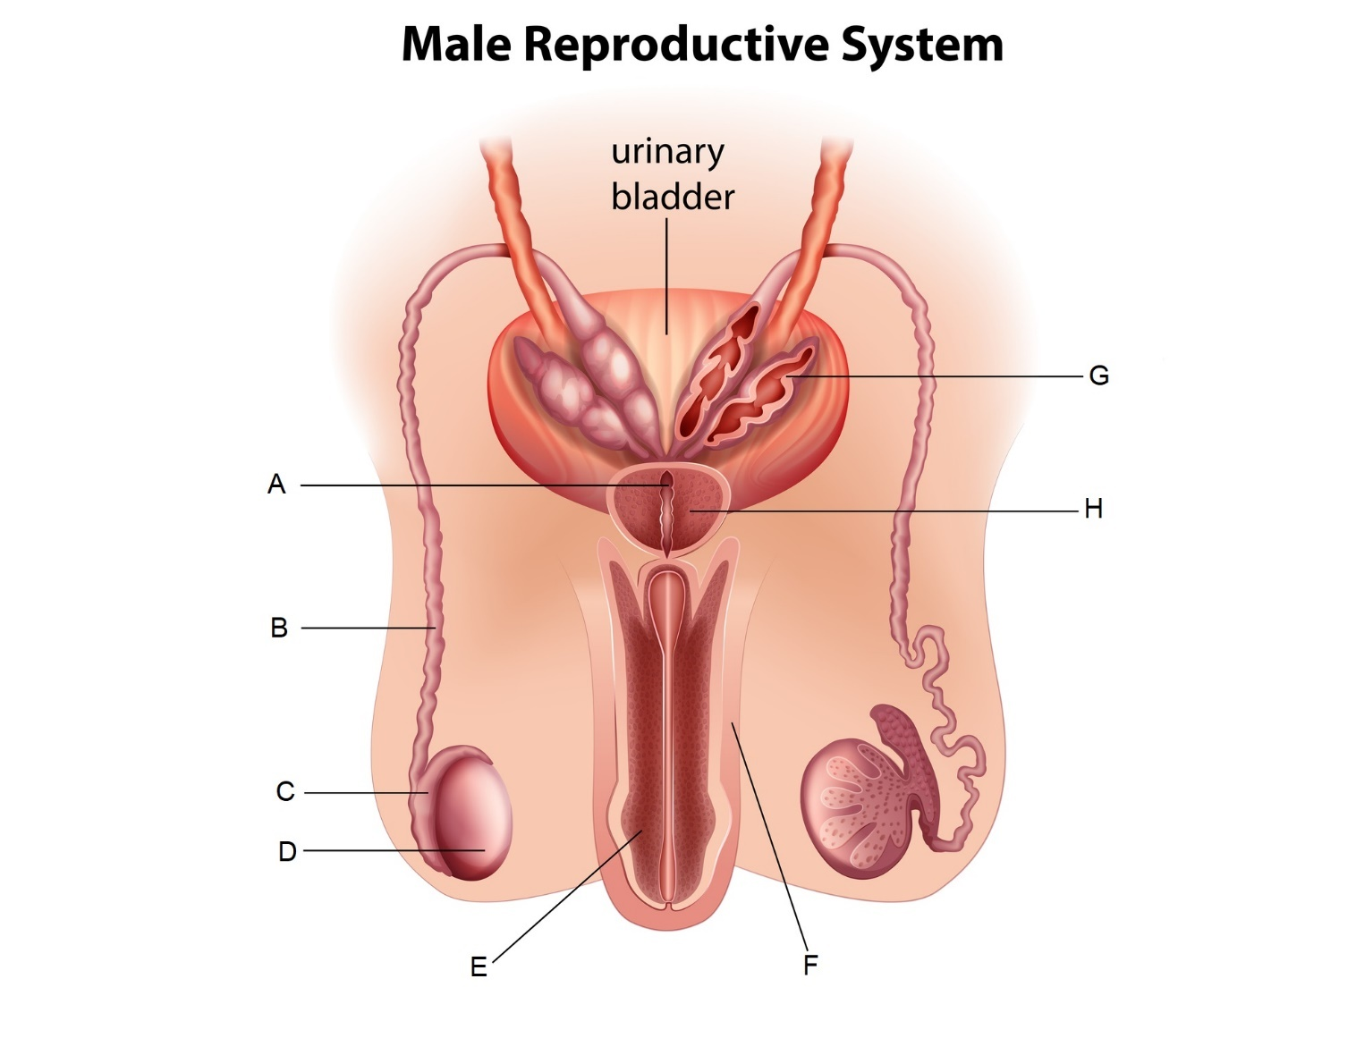

13. Which of the following labels indicates the epididymis?

(a) A
(b) B
(c) C
(d) D

14. Which of the following most correctly describes the function of the part labelled H?

(a) It secretes a fluid rich in sugars that makes up the majority of the seminal fluid.
(b) It secretes a small amount of fluid that acts as a lubricant.
(c) It secretes an alkaline fluid that helps to neutralise the acidity in the vagina.
(d) It secretes a fluid rich in proteins to provide spermatozoa with strength for swimming.

15. A relatively simple surgical procedure to sterilise males and prevent conception usually involves which of the following parts?

(a) A
(b) B
(c) C
(d) D

16. Pairs of homologous chromosomes line up together at the equator during

(a) metaphase.
(b) metaphase I.
(c) metaphase II.
(d) anaphase I.

17. Fertilisation occurs in the

(a) ovary.
(b) fallopian tube.
(c) uterus.
(d) vagina

18. Which of the following is the correct name given to the biotechnological technique that can allow scientists to produce a DNA profile?

(a) polymerase chain reaction
(b) genetic engineering
(c) gel electrophoresis
(d) genetic probing

19. Which of the following statements is correct?

(a) A gene is a section of DNA.
(b) An allele contains two genes.
(c) A chromosome contains only one gene.
(d) A gene is made up of several chromosomes.

20. The hormone testosterone

(a) is produced by the seminiferous tubules.
(b) has no influence on the production of sperm in the testes.
(c) results in the secondary sex characteristics of males.
(d) is secreted by sperm as they mature.

21. Which of the following methods of contraception prevent fertilisation from occurring?

(a) the morning after pill and the condom
(b) the morning after pill and an IUD
(c) an IUD and a diaphragm
(d) a diaphragm and sterilisation

22. Gametogenesis produces

(a) 4 viable sperm cells in males, each with N chromosomes.
(b) 4 viable egg cells in females, each with N chromosomes.
(c) 2 viable sperm cells in males, each with 2N chromosomes.
(d) 1 viable egg cell in females with 2N chromosomes.

23. Gonorrhoea is a sexually transmitted infection that

(a) affects the mucous membranes of the urinary and genital tracts.
(b) has three main stages.
(c) can affect an embryo via the placenta.
(d) is caused by a virus.

24. The genotype of an individual

(a) is always the same as the phenotype.
(b) refers to the visible traits of an individual.
(c) refers to the types of alleles a person has.
(d) is indicated by the presence or absence of an X or Y chromosome.

25. The ductus venosus allows for blood to bypass which of the following organs during foetal circulation?

(a) lungs
(b) kidneys
(c) stomach
(d) liver

End of Section One

This page has been left blank intentionally

Section Two: Short answer 50% (90 Marks)

This section has seven questions. Answer all questions. Write your answers in the spaces provided.

Supplementary pages for planning/continuing your answers to questions are provided at the end of this Question/Answer booklet. If you use these pages to continue an answer, indicate at the original answer where the answer is continued, i.e. give the page number.

Suggested working time: 80 minutes.

Question 26 (16 marks)

A combination of chemotherapy and radiotherapy is being recommended for some forms of small tumour lung cancer. One randomised clinical trial tested the effect of this combined treatment on lung cancer sufferers.

This trial involved splitting a group of 200 people with lung cancer, at random, into a control group and an experimental group. Those in the experimental group were given the treatment once-daily over a period of 6 months, while those in the control group received a placebo. The patients were given a CT scan monthly to determine the percentage change in the size of the tumour.

The table below show the reduction in the size of tumours, as a percentage, in the two groups over time.

 | Average percentage (%) of tumour remaining each month
 | Month 1 | Month 2 | Month 3 | Month 4 | Month 5 | Month 6
Experimental Group | 90 | 82 | 70 | 63 | 51 | 38
Control Group | 97 | 94 | 92 | 95 | 88 | 90

(a) Explain the purpose of the control group in this investigation. (2 marks)

______________________________________________________________________

______________________________________________________________________

______________________________________________________________________

(b) Identify two controlled variables in this investigation. (2 marks)

______________________________________________________________________

______________________________________________________________________

(c) Suggest a possible hypothesis for this investigation. (2 marks)

______________________________________________________________________

______________________________________________________________________

______________________________________________________________________

______________________________________________________________________

(d) Graph the results of the clinical trial on the grid below. (5 marks)

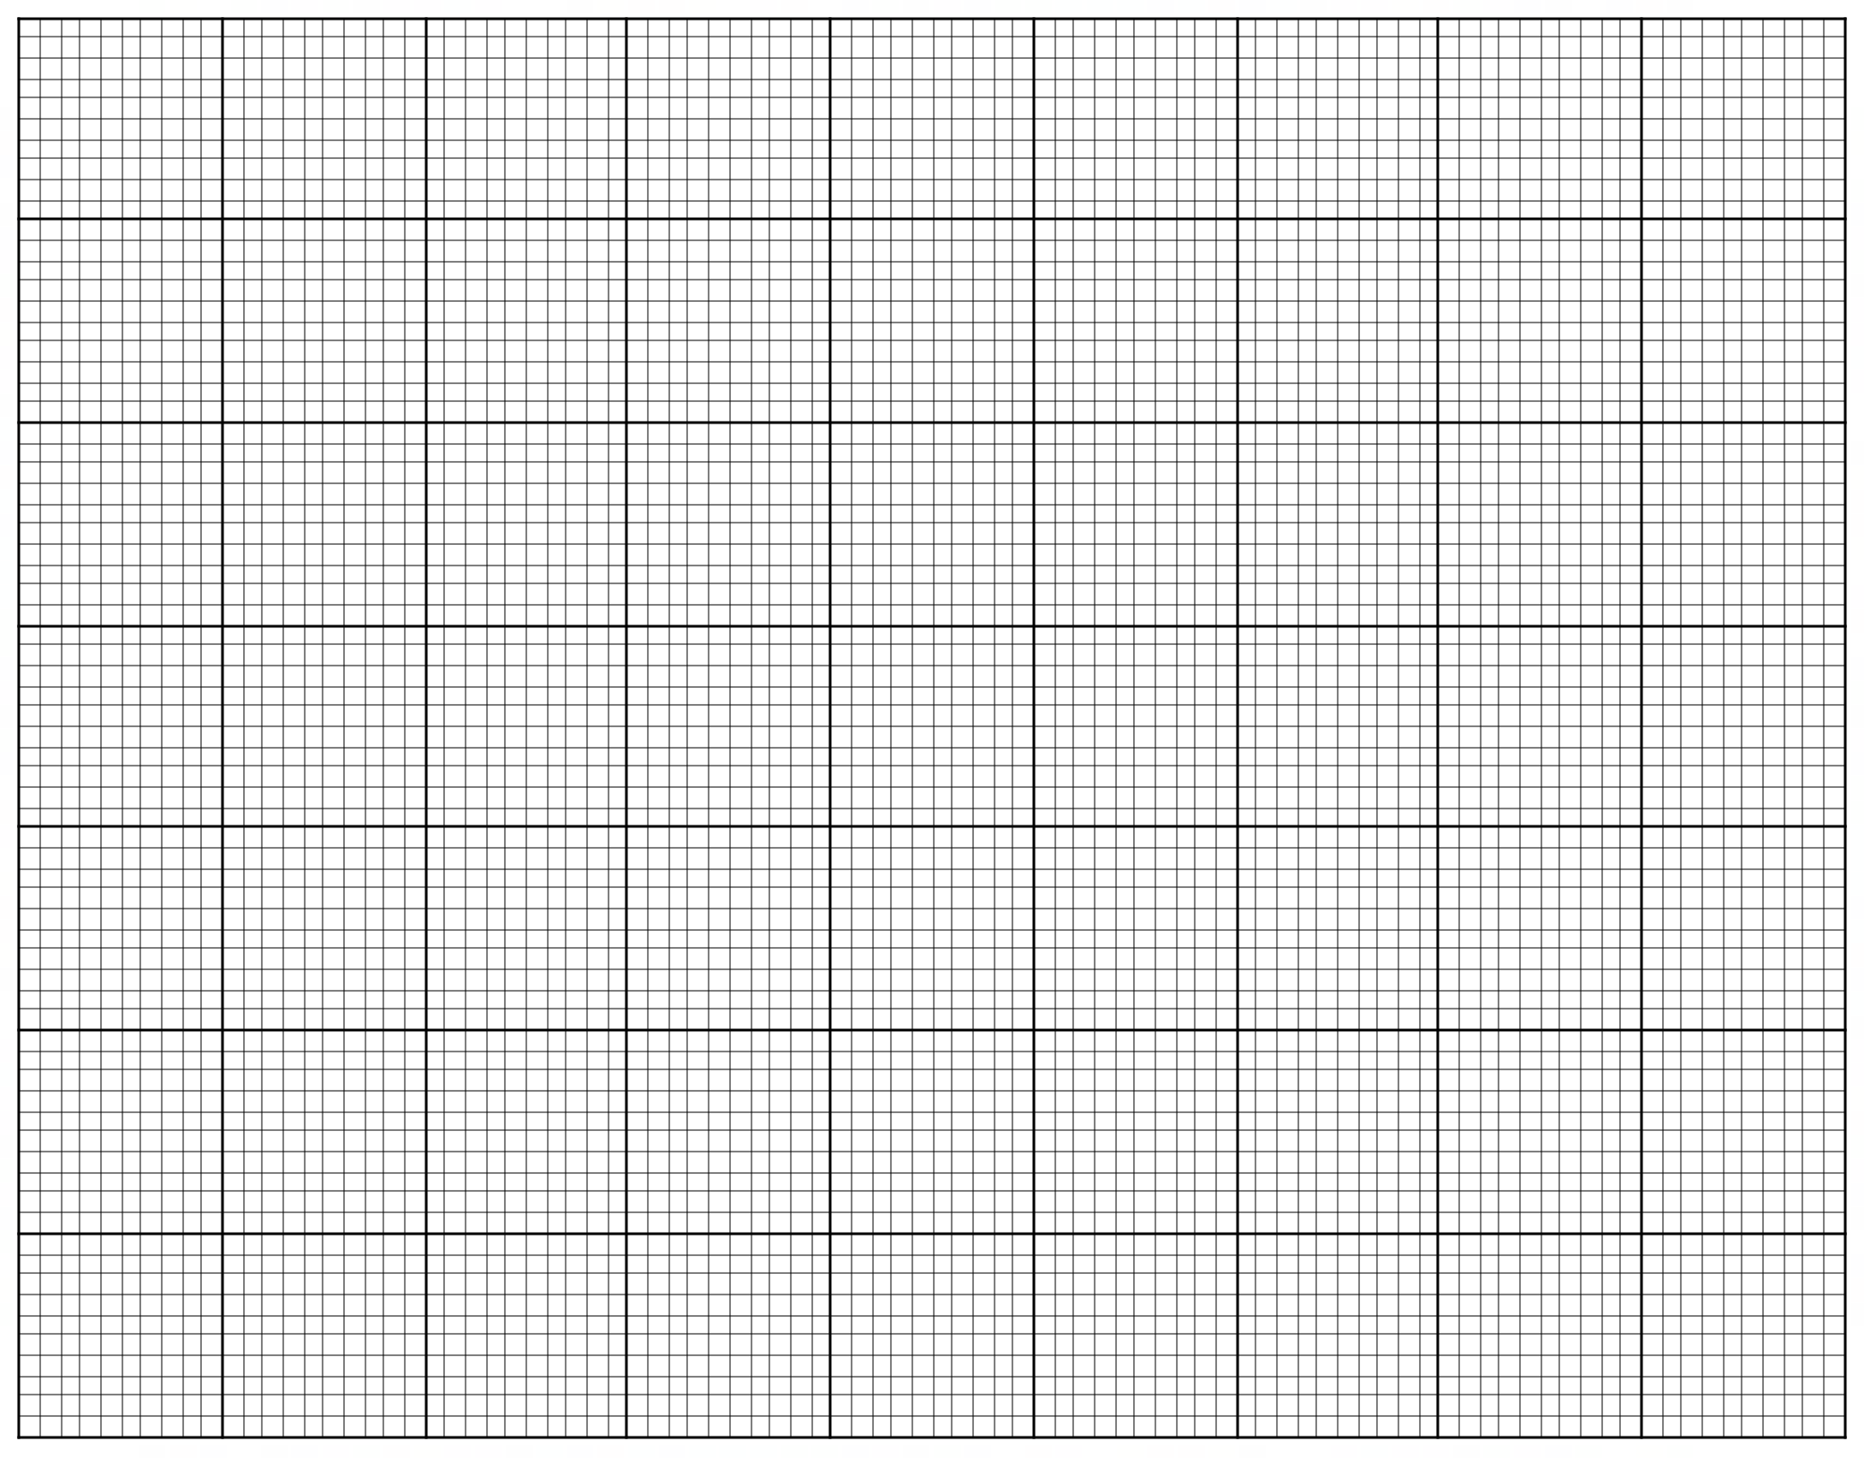

A spare grid is provided at the end of this Question/Answer Booklet. If you need to use it, cross
out this attempt and indicate that you have redrawn it on the spare grid.

Question 26 (continued)

(e) Outline a conclusion based on the data in the graph. (2 marks)

______________________________________________________________________

______________________________________________________________________

______________________________________________________________________

(f) Describe what is meant by an autosomal, recessive genetic condition. (3 marks)

______________________________________________________________________

______________________________________________________________________

______________________________________________________________________

______________________________________________________________________

______________________________________________________________________

______________________________________________________________________

______________________________________________________________________

______________________________________________________________________

______________________________________________________________________

This page has been left blank intentionally

Question 27 (16 marks)

The diagram below shows the process of protein synthesis occurring within a cell.

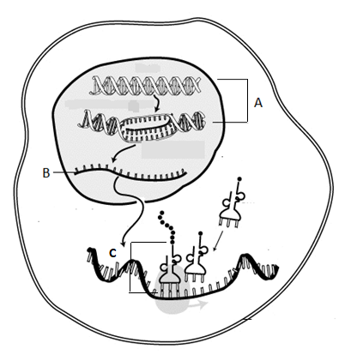

(a) Identify (3 marks)

(i) Process A

(ii) Structure B

(iii) Process C

(b) Explain the role of the nucleus in protein synthesis. (4 marks)

______________________________________________________________________

______________________________________________________________________

______________________________________________________________________

______________________________________________________________________

(c) The enzymes DNA helicase and DNA polymerase are involved in DNA replication. Describe the functions of these enzymes. (3 marks)

______________________________________________________________________

______________________________________________________________________

______________________________________________________________________

The way in which enzymes work can be shown using a lock and key model.

(d) Describe, using diagrams to support your answer, the lock and key model. Include in your answer why this model supports the specific nature of enzymes.
(6 marks)

Question 28 (10 marks)

The diagram below shows the structures of the male reproductive system.

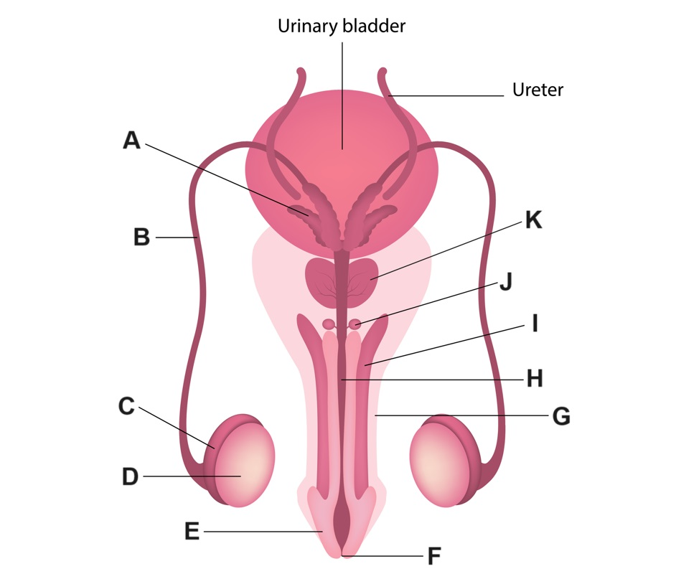

(a) Complete table below, outlining the function of the labelled parts. (3 marks)

Label | Function
C
D
H

(b) Name and explain the sterilisation method of contraception that involves making an incision to remove part of the structure labelled B. (3 marks)

______________________________________________________________________

______________________________________________________________________

______________________________________________________________________

______________________________________________________________________

______________________________________________________________________

______________________________________________________________________
(c) Explain, referring to the relevant labelled structures in the diagram, why a man can still produce seminal fluid even after undertaking the procedure from part (b). (4 marks)

______________________________________________________________________

______________________________________________________________________

______________________________________________________________________

______________________________________________________________________

______________________________________________________________________

______________________________________________________________________

______________________________________________________________________

______________________________________________________________________

______________________________________________________________________

______________________________________________________________________

______________________________________________________________________

Question 29 (12 marks)

The diagram below shows the structure of DNA.

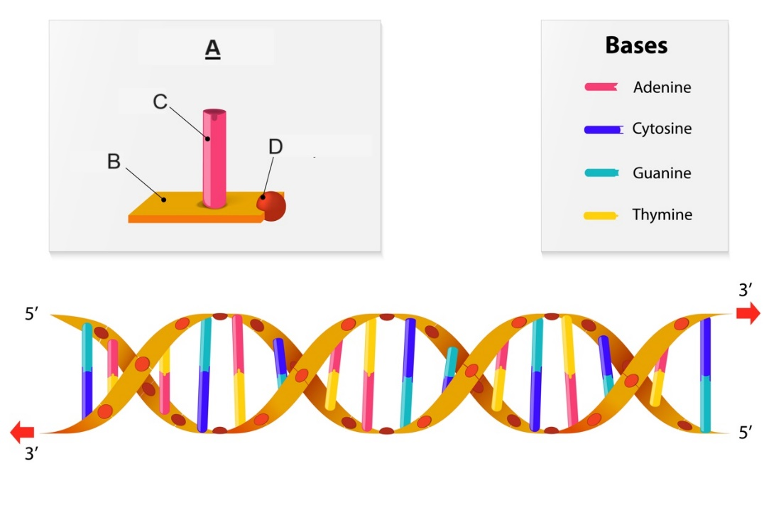

(a) State the name and describe the structure of the building blocks of DNA, labelled A on the diagram. (4 marks)

______________________________________________________________________

______________________________________________________________________

______________________________________________________________________

______________________________________________________________________

______________________________________________________________________

(b) DNA needs to be replicated before mitosis takes place. Explain the importance of DNA replication for mitosis. (3 marks)

______________________________________________________________________

______________________________________________________________________

______________________________________________________________________

______________________________________________________________________

______________________________________________________________________

______________________________________________________________________

______________________________________________________________________

______________________________________________________________________

(c) During mitosis DNA can be found in structures known as chromosomes. Describe the structure of chromosomes, and outline what occurs to chromosomes during metaphase and anaphase in mitosis. (5 marks)

______________________________________________________________________

______________________________________________________________________

______________________________________________________________________

______________________________________________________________________

______________________________________________________________________

______________________________________________________________________

______________________________________________________________________

______________________________________________________________________

______________________________________________________________________

______________________________________________________________________

______________________________________________________________________

______________________________________________________________________

______________________________________________________________________

Question 30 (18 marks)

Blood groups in humans are an example of a phenotype that can be determined by multiple alleles.

(a) Complete the table below showing the possible genotypes for each blood group.
(4 marks)

Blood group | Genotypes
A
B
AB
O

(b) The ABO blood grouping system is an example of codominance. Define this term.
(1 mark)

(c) Mrs Smith has Type A blood, but she is not sure if she is homozygous or heterozygous. Mr Smith is completely unsure of his blood type. Their children have the following blood types: Daniel has type O blood, Michael and Nathan have type A blood, Kyla has type B blood and Oliver has type AB blood.

What are the possible genotypes of both Mr and Mrs Smith? Use a Punnett square to justify your answer. (4 marks)
(d) Haemophilia is a recessive, sex-linked disorder which causes an inability to clot when
bleeding.

Roy and Elaine Brown were married in 1986. Neither Roy nor Elaine had haemophilia. They had two daughters and then a son. Both daughters, Alicia and Candace, had normal clotting abilities and never had any children of their own. Their son, Mike, had haemophilia and married Beth, who did not have the disease. They had two children of their own, first Ethan and then Ella. Surprisingly, Ella had haemophilia, but Ethan did not.

(i) Draw the pedigree that traces the haemophilia disorder in this family. (4 marks)

(ii) Write the genotypes for: (2 marks)

Elaine
Ethan

(iii) Why is it surprising that Ella had haemophilia, but Ethan did not? (2 marks)

(iv) If Ella has children, what do you automatically know about the phenotype of her sons? (1 mark)

Question 31 (16 marks)

The figure below shows the changes in hormones levels in females during the ovarian and menstrual cycle.
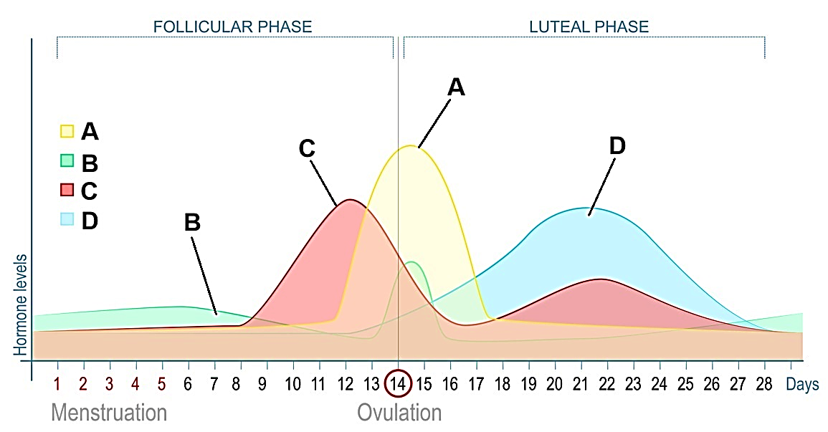

(a) Identify hormones A and C. (2 marks)

A ________________________________________________________________

C ________________________________________________________________

(b) Describe the role of hormone D in the ovarian and menstrual cycle. (2 marks)

______________________________________________________________________

______________________________________________________________________

______________________________________________________________________

______________________________________________________________________

(c) State which two hormones from the diagram can be found in the female contraceptive pill and explain the role of one of these hormones used in this form of contraception.
(4 marks)

______________________________________________________________________

______________________________________________________________________

______________________________________________________________________

______________________________________________________________________

______________________________________________________________________

______________________________________________________________________

______________________________________________________________________

______________________________________________________________________

______________________________________________________________________

______________________________________________________________________

______________________________________________________________________

(d) During the process of in-vitro fertilisation (IVF), the woman needs to produce a large number of eggs to increase the likelihood of the procedure being effective. State which hormone from the diagram would be given synthetically to stimulate this process and, explain your answer. (3 marks)

______________________________________________________________________

______________________________________________________________________

______________________________________________________________________

______________________________________________________________________

______________________________________________________________________

______________________________________________________________________

______________________________________________________________________

______________________________________________________________________

The diagram below shows part of the placenta and the umbilical cord attached to a foetus.
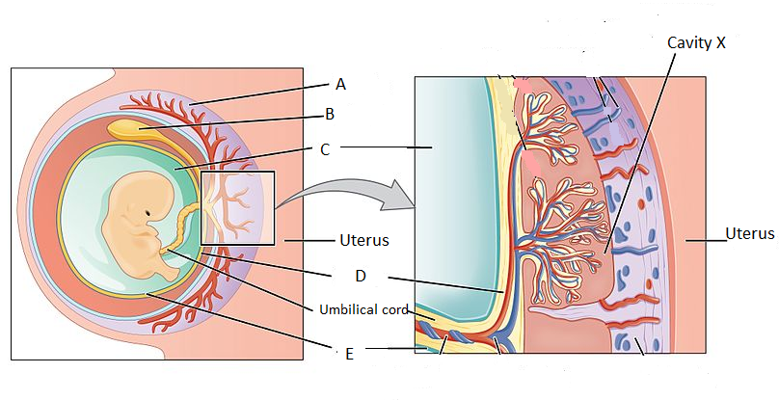

(e) (i) Name two substances that would be in higher concentration in the umbilical vein than in the umbilical artery. (2 marks)

(ii) Cavity X contains maternal blood. Suggest why it is advantageous to have this blood in a cavity rather than contained within a blood vessel. (3 marks)

End of Section Two
Section Three: Extended answer 20% (35 Marks)

This section has two questions. You must answer BOTH questions.

Questions 32 and 33 are from Unit 2. Answer BOTH question from Unit 2.

Responses could include clearly labelled diagrams with explanatory notes; list of points with linking sentences; clearly labelled tables and graphs; and annotated flow diagrams with introductory notes.

Supplementary pages for planning/continuing your answers to questions are provided at the end of this Question/Answer booklet. If you use these pages to continue an answer, indicate at the original answer where the answer is continued, i.e. give the page number.

Suggested working time: 40 minutes.

Unit 2

Answer Question 32 AND Question 33.

Question 32 (20 marks)

Gene expression refers to the phenotypic expression of genes and is achieved through protein synthesis. The expression of genes is determined by a combination of alleles which are expressed dependent on their mode of inheritance.

(a) Describe transcription and translation. (12 marks)

(b) Describe how autosomal recessive and sex-linked recessive genetic disorders are inherited and expressed. Use examples of these disorders to support your answer.
(8 marks)

Question 33 (15 marks)

Germline, or germ cells, are the cells that give rise to the gametes in the ovaries and testes. These diploid cells are formed during embryonic and foetal development as a result of differentiation from unspecialised cells known as stem cells.

(a) Describe how gametes are produced through the processes of spermatogenesis and oogenesis. (15 marks)

END OF QUESTIONS
Question number: _______________

____________________________________________________________________________

____________________________________________________________________________

____________________________________________________________________________

____________________________________________________________________________

____________________________________________________________________________

____________________________________________________________________________

____________________________________________________________________________

____________________________________________________________________________

____________________________________________________________________________

____________________________________________________________________________

____________________________________________________________________________

____________________________________________________________________________

____________________________________________________________________________

____________________________________________________________________________

____________________________________________________________________________

____________________________________________________________________________

____________________________________________________________________________

____________________________________________________________________________

____________________________________________________________________________

____________________________________________________________________________

____________________________________________________________________________

____________________________________________________________________________

____________________________________________________________________________

____________________________________________________________________________

____________________________________________________________________________

____________________________________________________________________________
Question number: _______________

____________________________________________________________________________

____________________________________________________________________________

____________________________________________________________________________

____________________________________________________________________________

____________________________________________________________________________

____________________________________________________________________________

____________________________________________________________________________

____________________________________________________________________________

____________________________________________________________________________

____________________________________________________________________________

____________________________________________________________________________

____________________________________________________________________________

____________________________________________________________________________

____________________________________________________________________________

____________________________________________________________________________

____________________________________________________________________________

____________________________________________________________________________

____________________________________________________________________________

____________________________________________________________________________

____________________________________________________________________________

____________________________________________________________________________

____________________________________________________________________________

____________________________________________________________________________

____________________________________________________________________________

____________________________________________________________________________

____________________________________________________________________________
Question number: _______________

____________________________________________________________________________

____________________________________________________________________________

____________________________________________________________________________

____________________________________________________________________________

____________________________________________________________________________

____________________________________________________________________________

____________________________________________________________________________

____________________________________________________________________________

____________________________________________________________________________

____________________________________________________________________________

____________________________________________________________________________

____________________________________________________________________________

____________________________________________________________________________

____________________________________________________________________________

____________________________________________________________________________

____________________________________________________________________________

____________________________________________________________________________

____________________________________________________________________________

____________________________________________________________________________

____________________________________________________________________________

____________________________________________________________________________

____________________________________________________________________________

____________________________________________________________________________

____________________________________________________________________________

____________________________________________________________________________

____________________________________________________________________________
Question number: _______________

____________________________________________________________________________

____________________________________________________________________________

____________________________________________________________________________

____________________________________________________________________________

____________________________________________________________________________

____________________________________________________________________________

____________________________________________________________________________

____________________________________________________________________________

____________________________________________________________________________

____________________________________________________________________________

____________________________________________________________________________

____________________________________________________________________________

____________________________________________________________________________

____________________________________________________________________________

____________________________________________________________________________

____________________________________________________________________________

____________________________________________________________________________

____________________________________________________________________________

____________________________________________________________________________

____________________________________________________________________________

____________________________________________________________________________

____________________________________________________________________________

____________________________________________________________________________

____________________________________________________________________________

____________________________________________________________________________

____________________________________________________________________________
Question number: _______________

____________________________________________________________________________

____________________________________________________________________________

____________________________________________________________________________

____________________________________________________________________________

____________________________________________________________________________

____________________________________________________________________________

____________________________________________________________________________

____________________________________________________________________________

____________________________________________________________________________

____________________________________________________________________________

____________________________________________________________________________

____________________________________________________________________________

____________________________________________________________________________

____________________________________________________________________________

____________________________________________________________________________

____________________________________________________________________________

____________________________________________________________________________

____________________________________________________________________________

____________________________________________________________________________

____________________________________________________________________________

____________________________________________________________________________

____________________________________________________________________________

____________________________________________________________________________

____________________________________________________________________________

____________________________________________________________________________

____________________________________________________________________________

Question number: _______________

____________________________________________________________________________

____________________________________________________________________________

____________________________________________________________________________

____________________________________________________________________________

____________________________________________________________________________

____________________________________________________________________________

____________________________________________________________________________

____________________________________________________________________________

____________________________________________________________________________

____________________________________________________________________________

____________________________________________________________________________

____________________________________________________________________________

____________________________________________________________________________

____________________________________________________________________________

____________________________________________________________________________

____________________________________________________________________________

____________________________________________________________________________

____________________________________________________________________________

____________________________________________________________________________

____________________________________________________________________________

____________________________________________________________________________

____________________________________________________________________________

____________________________________________________________________________

____________________________________________________________________________

____________________________________________________________________________

____________________________________________________________________________
Question number: _______________

____________________________________________________________________________

____________________________________________________________________________

____________________________________________________________________________

____________________________________________________________________________

____________________________________________________________________________

____________________________________________________________________________

____________________________________________________________________________

____________________________________________________________________________

____________________________________________________________________________

____________________________________________________________________________

____________________________________________________________________________

____________________________________________________________________________

____________________________________________________________________________

____________________________________________________________________________

____________________________________________________________________________

____________________________________________________________________________

____________________________________________________________________________

____________________________________________________________________________

____________________________________________________________________________

____________________________________________________________________________

____________________________________________________________________________

____________________________________________________________________________

____________________________________________________________________________

____________________________________________________________________________

____________________________________________________________________________

____________________________________________________________________________
Question number: _______________

____________________________________________________________________________

____________________________________________________________________________

____________________________________________________________________________

____________________________________________________________________________

____________________________________________________________________________

____________________________________________________________________________

____________________________________________________________________________

____________________________________________________________________________

____________________________________________________________________________

____________________________________________________________________________

____________________________________________________________________________

____________________________________________________________________________

____________________________________________________________________________

____________________________________________________________________________

____________________________________________________________________________

____________________________________________________________________________

____________________________________________________________________________

____________________________________________________________________________

____________________________________________________________________________

____________________________________________________________________________

____________________________________________________________________________

____________________________________________________________________________

____________________________________________________________________________

____________________________________________________________________________

____________________________________________________________________________

____________________________________________________________________________
Question number: _______________

____________________________________________________________________________

____________________________________________________________________________

____________________________________________________________________________

____________________________________________________________________________

____________________________________________________________________________

____________________________________________________________________________

____________________________________________________________________________

____________________________________________________________________________

____________________________________________________________________________

____________________________________________________________________________

____________________________________________________________________________

____________________________________________________________________________

____________________________________________________________________________

____________________________________________________________________________

____________________________________________________________________________

____________________________________________________________________________

____________________________________________________________________________

____________________________________________________________________________

____________________________________________________________________________

____________________________________________________________________________

____________________________________________________________________________

____________________________________________________________________________

____________________________________________________________________________

____________________________________________________________________________

____________________________________________________________________________

____________________________________________________________________________
Question number: _______________

____________________________________________________________________________

____________________________________________________________________________

____________________________________________________________________________

____________________________________________________________________________

____________________________________________________________________________

____________________________________________________________________________

____________________________________________________________________________

____________________________________________________________________________

____________________________________________________________________________

____________________________________________________________________________

____________________________________________________________________________

____________________________________________________________________________

____________________________________________________________________________

____________________________________________________________________________

____________________________________________________________________________

____________________________________________________________________________

____________________________________________________________________________

____________________________________________________________________________

____________________________________________________________________________

____________________________________________________________________________

____________________________________________________________________________

____________________________________________________________________________

____________________________________________________________________________

____________________________________________________________________________

____________________________________________________________________________

____________________________________________________________________________
Supplementary page

Question number: _______________

____________________________________________________________________________

____________________________________________________________________________

____________________________________________________________________________

____________________________________________________________________________

____________________________________________________________________________

____________________________________________________________________________

____________________________________________________________________________

____________________________________________________________________________

____________________________________________________________________________

____________________________________________________________________________

____________________________________________________________________________

____________________________________________________________________________

____________________________________________________________________________

____________________________________________________________________________

____________________________________________________________________________

____________________________________________________________________________

____________________________________________________________________________

____________________________________________________________________________

____________________________________________________________________________

____________________________________________________________________________

____________________________________________________________________________

____________________________________________________________________________

____________________________________________________________________________

____________________________________________________________________________

____________________________________________________________________________
Supplementary page

Question number: _______________

____________________________________________________________________________

____________________________________________________________________________

____________________________________________________________________________

____________________________________________________________________________

____________________________________________________________________________

____________________________________________________________________________

____________________________________________________________________________

____________________________________________________________________________

____________________________________________________________________________

____________________________________________________________________________

____________________________________________________________________________

____________________________________________________________________________

____________________________________________________________________________

____________________________________________________________________________

____________________________________________________________________________

____________________________________________________________________________

____________________________________________________________________________

____________________________________________________________________________

____________________________________________________________________________

____________________________________________________________________________

____________________________________________________________________________

____________________________________________________________________________

____________________________________________________________________________

____________________________________________________________________________

____________________________________________________________________________
Supplementary page

Question number: _______________

____________________________________________________________________________

____________________________________________________________________________

____________________________________________________________________________

____________________________________________________________________________

____________________________________________________________________________

____________________________________________________________________________

____________________________________________________________________________

____________________________________________________________________________

____________________________________________________________________________

____________________________________________________________________________

____________________________________________________________________________

____________________________________________________________________________

____________________________________________________________________________

____________________________________________________________________________

____________________________________________________________________________

____________________________________________________________________________

____________________________________________________________________________

____________________________________________________________________________

____________________________________________________________________________

____________________________________________________________________________

____________________________________________________________________________

____________________________________________________________________________

____________________________________________________________________________

____________________________________________________________________________

____________________________________________________________________________

Spare grid



